**SYSTEM PROPOSAL**

# Table of Contents

1 OVERVIEW 3

1.1 Purpose, Scope and Objectives 3

2 SYSTEM REQUEST 3

2.1 Project sponsor 3

2.2 Business need 3

2.3 Business requirements 3

2.4 Business value 3

2.5 Special issues 3

3 FEASIBILITY ANALYSIS 3

3.1 Technical feasibility 4

3.2 Economic Feasibility 4

3.3 Organizational Feasibility 4

4 WORK PLAN and GANTT CHART 4

5 REQUIREMENT DEFINITION 4

6 FUNCTIONAL MODELS 4

7 STRUCTURAM MODELS 4

8 BEHAVIORAL MODELS 4

9 APPENDECIS 4

9.1 <Appendix Name> 4

# OVERVIEW

* 1. Purpose, Scope and Objectives

**-purpose**

**This project aims to teach different languages ​​to all people of all ages, such as school and university students, employees and non-employees in return for an agreed upon fee.**

**-objectives**

**1- Develop language skills for school and university students.**

**2- Providing language learning for people of all ages.**

**3- Granting an experience certificate to each trainee.**

**4- Obtaining a fee for each trainee.**

**5- The possibility of providing various job opportunities.**

**2. SYSTEM REQUEST**

**2.1 Project sponsor**

**The Ministry of Education, a governmental body established in 1956, is the official sponsor of education in Jordan for all stages of learning**

**2.2. BUSNESS NEED**

**Continuing to target business needs to achieve results on time and reach the goal of establishing the project in achieving profits through project implementation and work on it**

**2.3 BUSINESS REQUIREMENTS**

**The Internet must be provided to connect the learning system with the learners. After that, each trainee is registered through the learning system through cards containing the e-mail and password to be able to create**

**a special educational account for the trainee and use it in the education stag**

**2.4 BUSNESS VALUE**

* **Ease of use of the system to suit all ages.**
* **Reducing the costs incurred by the trainees.**
* **Increasing trust between the teaching staff and the trainees.**
* **Granting strong and approved certificates from the system to each trainee.**
* **Providing good image and sound quality in the system.**
* **Access to a large number of trainees from all over the world.**

**2.5 Special Issues**

* **The inability to access the system due to the unavailability of the internet or an electronic learning device.**
* **Obtaining system approval from the Ministry of Education.**
* **Lack of desire for e-learning for some trainees and their preference over face-to-face learning in educational halls.**

**3. FEASIBILITY ANALYSIS**

**3.1 Technical feasibility :**

* Choosing the appropriate site for the project.
* Choosing the right machines and production equipment.
* Estimation of the project needs of production requirements and elements.
* Determining the production method, production processes and approved technology.

**3.2 Economic Feasibility:**

* The economic feasibility study is one of the most important and prominent tools that help the person conducting the study to make the right decisions appropriate to the project.
* The economic feasibility study contributes to presenting a complete system of project data, and analyzing this data in a way that allows the investor to take the right step.

|  |  |  |  |
| --- | --- | --- | --- |
| **Project costs** | **Developer salaries** | **other** | **Total cost** |
| *4500 hardware* | *1200*  *Developer-1-* | *2000* | *17.900* |
| *7000*  *software* | *1500*  *Developer-2-* | *1700* |

**3.3 Organizational Feasibility**

* The organizational and administrative feasibility study means the study that is conducted with the aim of preparing the administrative organization of the project to be implemented, designing all the administrative systems for it, and ensuring that this organization and those systems will be valid in order for the investment project to achieve the goals for which it was established, whether for the public of users or for the public interest.
* Another main reason for the importance of the organizing process is to familiarize each person with the aspects of the activity he is required to perform, as this helps him to focus on carrying out the work assigned to him and reduces the possibilities of misunderstanding or confusion, in addition to determining the proper behavior of work relations in the organization, where each person knows the place The one who occupies him in it and knows his powers, responsibilities and relations, whether in relation to his superiors, colleagues or subordinates.

**4. WORK PLAN AND GANTT CHART**

|  |  |  |  |  |
| --- | --- | --- | --- | --- |
| DESCRIPTION | Responsibility | START DATE | END DATE | DURATION |
| Fesability Study | Hussam | 1-Apr-20 | 14-Apr-20 | 13 |
| Requirement Elicitation | Mohammed + Hussam | 14-Apr-20 | 17-Aug-20 | 123 |
| Requirement Analysis | Mohammed + Hussam | 20-Apr-20 | 17-Sep-20 | 147 |
| Software Design | Mohammed | 18-Sep-20 | 18-Nov-20 | 60 |
| Software Implementation | Hussam | 19-Nov-20 | 30-Dec-20 | 41 |
| Software V&V | Mohammed + Hussam | 30-Apr-20 | 20-Jan-21 | 260 |
| Software Deployment | Mohammed | 20-Jan-21 | 21-Feb-21 | 31 |
| Documentation | All | 20-Apr-20 | 20-Jan-21 | 270 |

|  |  |  |
| --- | --- | --- |
| Expected Outcome | Data Source and Evaluation Methodology | comments |
| Capable of making a decent profit. | Excellent | Obtaining reliable system information and data |
| Make a schedule for the project, and know the expected cost of the project. | Medium | Discuss and study requirements with project owners. |
| for project program success. | Poor | Can communicate with customers and users of the system in this process. |
| Through which it is possible to find the best solutions and solve the problems facing the system. | Medium | A strong security system must be in place to protect it from external attacks. |
| To operate, manage and control the system. | Medium | Internet must be available. |
| To ensure that the project meets the specifications and that it works the way it is. | Excellent | Check for errors after executing the system. |
| To make available and update the software system for the intended users. | Medium | Obtaining system approval from the Ministry of Education. |
| To understand the system software and how to use it. | Excellent | This process may take a lot of time. |

|  |  |  |  |  |  |  |  |  |  |  |  |  |  |  |  |  |  |  |  |  |  |  |  |  |
| --- | --- | --- | --- | --- | --- | --- | --- | --- | --- | --- | --- | --- | --- | --- | --- | --- | --- | --- | --- | --- | --- | --- | --- | --- |
| |  | | --- | |  | | | | | | | | | | | | | |  |  |  |  |  |  |  |  |  |  |  |
|  | | | | | | | | | | | | |  |  |  |  |  |  |  |  |  |  |  |
|  | | | | | | | | | | | | |  |  |  |  |  |  |  |  |  |  |  |
|  | | | | | | | | | | | | |  |  |  |  |  |  |  |  |  |  |  |
|  | | | | | | | | | | | | |  |  |  |  |  |  |  |  |  |  |  |
|  | | | | | | | | | | | | |  |  |  |  |  |  |  |  |  |  |  |
|  | | | | | | | | | | | | |  |  |  |  |  |  |  |  |  |  |  |
| **5. Requirements Definition**  **5.1 Functional Requirement**   * **Student**  1. **The system will allow students to access their own pages throught e-mail and password.** 2. **The system will allow students to view their interactive and recorded lectures.** 3. **The system will allow students to turn in their assignments.** 4. **The system will allow students to submit their exams.**  * **Questionnaires**  1. **The system will allow specify the duration of the educational session 45 minutes.** 2. **The system will allow the recording of each educational session for the students.** 3. **The system will allow students to interact and discuss with each other in order to participate and develop skills.**  * **Doctors**  1. **The system will allow Doctors to access their own pages through e-mail and password.** 2. **The system will allow doctors to set up a teaching room.** 3. **The system will allow doctors to create assignments and tests for students.** 4. **The system should allow doctors to send one message to all students.**  * **Interviews**  1. **The system will allow the doctors to save files and documents in the system.** 2. **The system will allow doctors to use Microsoft programs during the educational session.** 3. **The system will allow doctors to record each educational session and save it in the system.**  * **Registerirs**  1. **The system will allow the registrant to access all student pages.** 2. **The system will allow the registrar to submit all educational materials.** 3. **The system will allow the registrar to open and close sections for students.** 4. **The system will allow the registrar Obtain student information such as fees and student marks.**  * **Interviews**  1. **The system will allow the registrar to send alerts and notes to all students at the same time.** 2. **The system will allow the registrar to divide students into groups in all subjects.**   **5.2 Non Functional Requirement**   * **Operational**  1. **The learning system must run on computers, tablets, and smart phones.** 2. **The learning system must support its installation on Android and IOS in mobile phones.** 3. **The learning system on windows 10 only run in computers.**  * **Performance**  1. **The system should support good performance when used by 1000 people at the same time.** 2. **The system should provide a fast user performance of 3 seconds while attending a learning session.** 3. **The system should be more simple and easy to use for the users.**  * **Security**  1. **Providing protection programs for the education system to avoid penetration.** 2. **No one from outside is allowed to enter the system.** 3. **No student can access another student's account to use and view it.** 4. **Grant permissions only to the teacher to access student accounts.**  * **Cultural and Political**  1. **Commitment to the set time for the lessons because the learner and the teacher are present at the same time.** 2. **the system is available in more than one use language.**   **6. Functional Models**  **6.1 Use Case Diagram**  **https://tzlpnwtlon.us-06.visual-paradigm.com/rest/diagrams/projects/clipboard/1_0tjlqX6FYDwCHQha?dummy=E5I_qX6Ecqi4EQYF** | | | | | | | | | | | | |  |  |  |  |  |  |  |  |  |  |  |
|  | | | | | | | | | | | | |  |  |  |  |  |  |  |  |  |  |  |
|  | | | | | | | | | | | | |  |  |  |  |  |  |  |  |  |  |  |
|  | | | | | | | | | | | | |  |  |  |  |  |  |  |  |  |  |  |
|  | | | | | | | | | | | | |  |  |  |  |  |  |  |  |  |  |  |
|  | | | | | | | | | | | | |  |  |  |  |  |  |  |  |  |  |  |
|  | | | | | | | | | | | | |  |  |  |  |  |  |  |  |  |  |  |
|  | | | | | | | | | | | | |  |  |  |  |  |  |  |  |  |  |  |
|  |  |  |  |  |  |  |  |  |  |  | |
|  |  |  |  |  |  |  |  |  |  |  | |
|  |  |  |  |  |  |  |  |  |  |  | |
|  | | | | | | | | | | |  | | |  |  |  |  |  |  |  |  |  |  |
|  | | | | | | | | | | |  | | |  |  |  |  |  |  |  |  |  |  |
|  | | | | | | | | | | |  | | |  |  |  |  |  |  |  |  |  |  |
| **6.2  Use Case Description** | | | | | | | | | | |  | | |  |  |  |  |  |  |  |  |  |  |
|  | | | | | | | | | | |  | | |  |  |  |  |  |  |  |  |  |  |

|  |  |  |
| --- | --- | --- |
| **Use Case Number:** | **st-01** | |
| **Use Case Name:** | **class registration** | |
| **Actor (s):** | **student** | |
| **Maturity:** | **high** | |
| **Summary:** | **The use case is initiated by students to complete their registration and then select the materials they need to register.** | |
| **Basic Course of Events:** | **Actor action**  **1- This use case starts when students recording their class.**  **3- The student determines the subjects allowed to him.**  **6- The student confirms that the materials are correct.**  **8- This use case ends when the student's enrollment in the selected subjects is confirmed.** | **System Response**  **2- The system will display the materials that the student is allowed to select.**  **4- The system verifies the correctness of the subjects chosen by the student.**  **5- The system asks the student to confirm the items he selected.**  **7-The system installs the materials chosen by the student and displays them on the student's page.** |
| **Alternate Paths:** | **Identification of the student subjects not allowed to register. The system returns it to step 2.** | |
| **Exception Paths:** | **If the student registers more than one subject at the same time. The system immediately returns to step 2.** | |
| **Extension Points:** | **1- the courses not allowed for registration.**  **2- courses time similarity** | |
| **Triggers:** | **Doctors, students or registrars when they want to register.** | |
| **Assumptions:** | **The skills required of doctors and students to implement the steps required to achieve the registration process.** | |
| **Preconditions:** | **The system is working properly.  The student must have an active university account.** | |
| **Post Conditions:** | **1- All subjects selected by the student appear on his personal page.  2- Adding the student inside the educational room for each subject.** | |
| **Reference - Business Rules** | **See Business Rules section: 3.5.1 and 2.3.2** | |
| **Author (s):** | **1- Mohammed Fareed Tbakhi  2- Aziz Ibrahim Lotfi Aldwik** | |
| **Date :** | **11-1-2022** | |

**6.3  Activity Diagrams**

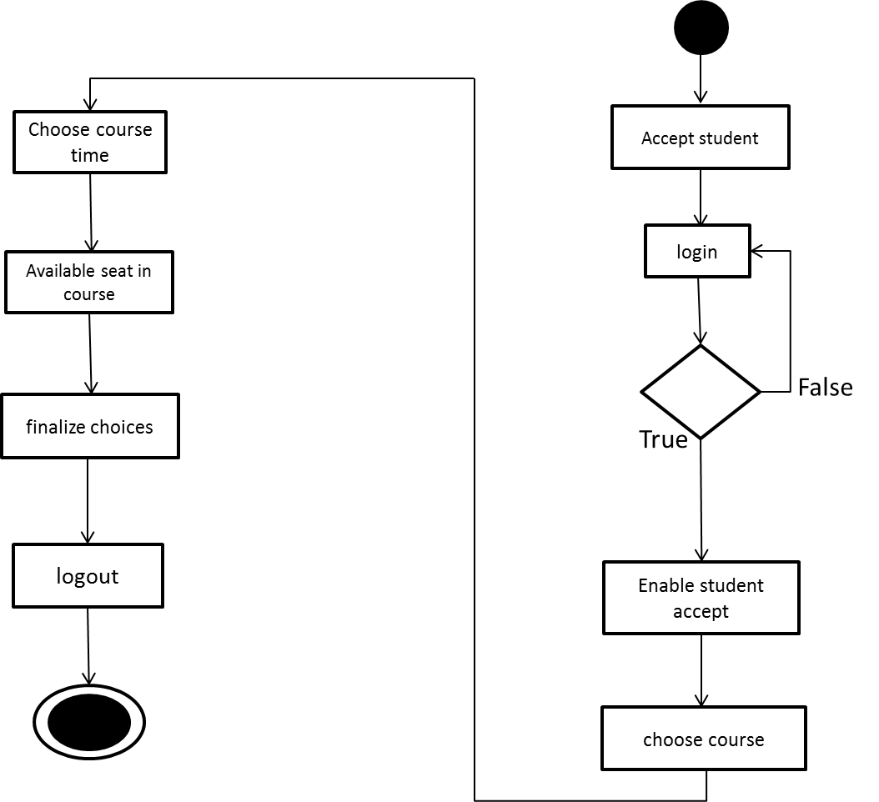

**7. STRUCTURAM MODELS**

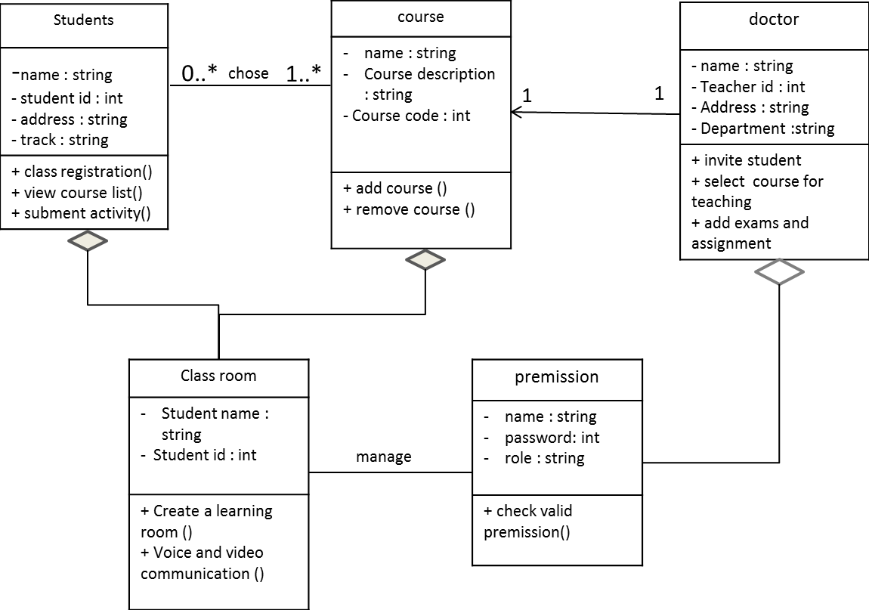

**8. BEHAVIORAL MODELS**

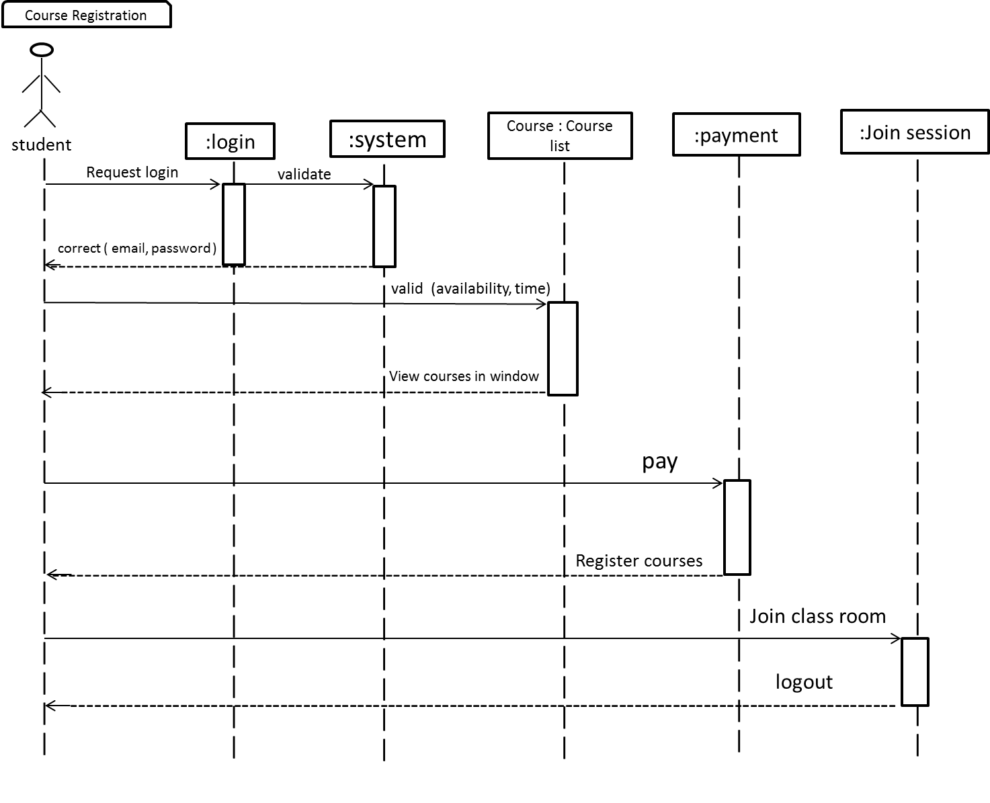

**9. APPENDECIS**

* **9.1 Questionnaires**

**https://forms.gle/XCe4RbSNtMdJsUiR6**